Create a program that calculates a projectile’s height and distance.

A launcher is at a position x0 = 0, y0 = h_initial, pointing at some angle, theta, which is given in degrees and is between 0 and 90 degrees.

Collect information:

**Units:** ask the user if they want to input values in feet or meters, if in feet, you will have to convert to meters before doing calculations.

**alpha**: angle cannon is pointing in degrees, between 0 and 90 degrees

**muzzle_velocity**: Speed at which the projectile leaves the launcher, given in meters/second or feet/second depending on choice above. (conversion to meters/second may be necessary before doing calculations)

**target_distance:** horizontal target distance from launcher also given in units chosen above. (conversion to meters may be necessary before doing the calculations)

Formulas:

**max_height**: h_max

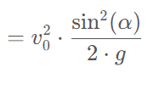

**flight_time:**

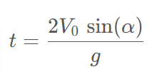

**x_distance:**



**g=9.81m/s2**

**1 foot = 0.3048m**

**1 meter = 3.28ft**

**Based on the inputted velocity and angle, compute the following values:**

*Flight time* in seconds accurate to a hundredth of a second (2 decimals)

*Max height* in meters and feet (printed to 2 decimal places)

*Distance* in meters and feet (printed to 1 decimal place)

**Considering only the muzzle_velocity, answer the following:**

*max_range*

*If the target is within range*